Key differences between mobile and web testing

|  |  |  |
| --- | --- | --- |
| **Aspect** | **Mobile Testing** | **Web Testing** |
| **Platform** | iOS, Android (native or hybrid apps) | Desktop or mobile browsers (Chrome, Firefox, etc.) |
| **Devices** | Real devices, emulators, simulators | Desktop computers, laptops, mobile browsers |
| **Input Methods** | Touch (tap, swipe, pinch, rotate) | Mouse and keyboard interactions |
| **Installation** | Requires app installation (.apk or .ipa) | No installation required – accessed via URL |
| **Interrupt Testing** | Must test for calls, SMS, app backgrounding, notifications | Not applicable |
| **Network Variability** | Test under Wi-Fi, mobile data (3G/4G/5G), offline mode | Typically stable connection (unless simulating issues) |
| **Screen Sizes** | Varies widely (phones, tablets, resolutions) | Mostly consistent for desktop; fewer screen breakpoints |
| **Performance Testing** | Must consider battery, CPU, memory usage | Focuses on page speed, load times, rendering |
| **Permissions** | Must test OS-level permissions (camera, GPS, storage) | Rarely applicable |
| **App Updates** | Includes testing for install, update, uninstall flows | Version control handled server-side |
| **Tooling** | Appium, Espresso, XCUITest, real device farms | Selenium, Cypress, Playwright, browser dev tools |
| **OS-Level Differences** | Must account for iOS vs Android behavior | Cross-browser compatibility (Chrome, Firefox, Safari, etc.) |

Tools you would use (Appium, etc.) and why

|  |  |  |
| --- | --- | --- |
| **Tool** | **Purpose** | **Why Use It** |
| **Appium** | Cross-platform mobile automation (iOS & Android) | Write tests in any language ,Supports real devices & emulators, Same test for both platforms |
| **Android Studio** | Develop and test Android apps with emulator & logs | Native Android tools, Easy to simulate devices and networks |
| **Xcode** | Develop and run iOS apps with simulator | Required for iOS builds and simulator, Debug iOS-specific issues |
| **TestNG / JUnit** | Java test frameworks | Organize test cases, Support for annotations, assertions, and reports |
| **Maven / Gradle** | Build tools and dependency management for Java projects | Manage Appium & Selenium libraries easily |
| **Newman** | CLI runner for Postman collections (for mobile APIs) | Test mobile app APIs in CI/CD |
| **BrowserStack / Sauce Labs** | Cloud-based device testing platforms | Access to a wide range of real devices without buying them |

Include example code snippets for basicmobile test scenarios

Setdecired

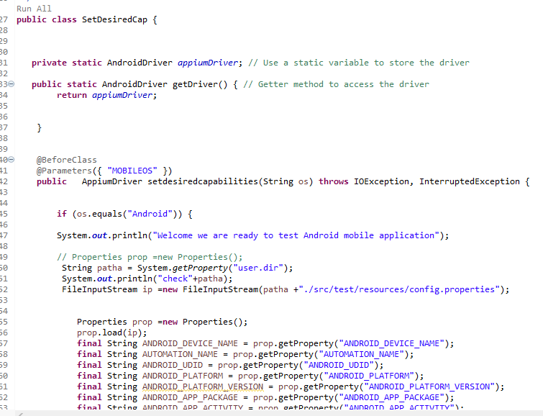

Logging page

Test Case class

Extend report

